**COSC 4351**

**Name: ___Jonathan Hirsch_____________**

800 points

**UML MVC Class Diagram Model to C#**, **Ruby**, **Python**, and **Php5** *.

Enhance your **UML MVC Class Diagram** Model submitted for the UML Tutorial (add pseudocode for **main**, **showSelection**, UC**RestoreCatalog**, **restoreCatalog**, UC**AddDVD**, **addDVD**, UC**DisplayDVDByCategory**, **displayDVDByCategory,** UC**SaveCatalog**, **saveCatalog)** and convert it to the following Classes in **C#**, **Ruby**, **Python**, and **Php5**\*.

Please attach your new UML MVC Class Diagram to BB Assignment.

You must use an IDE.

If not MVC Classes you will not get any points.

**DVD Collection Application Requirements:**

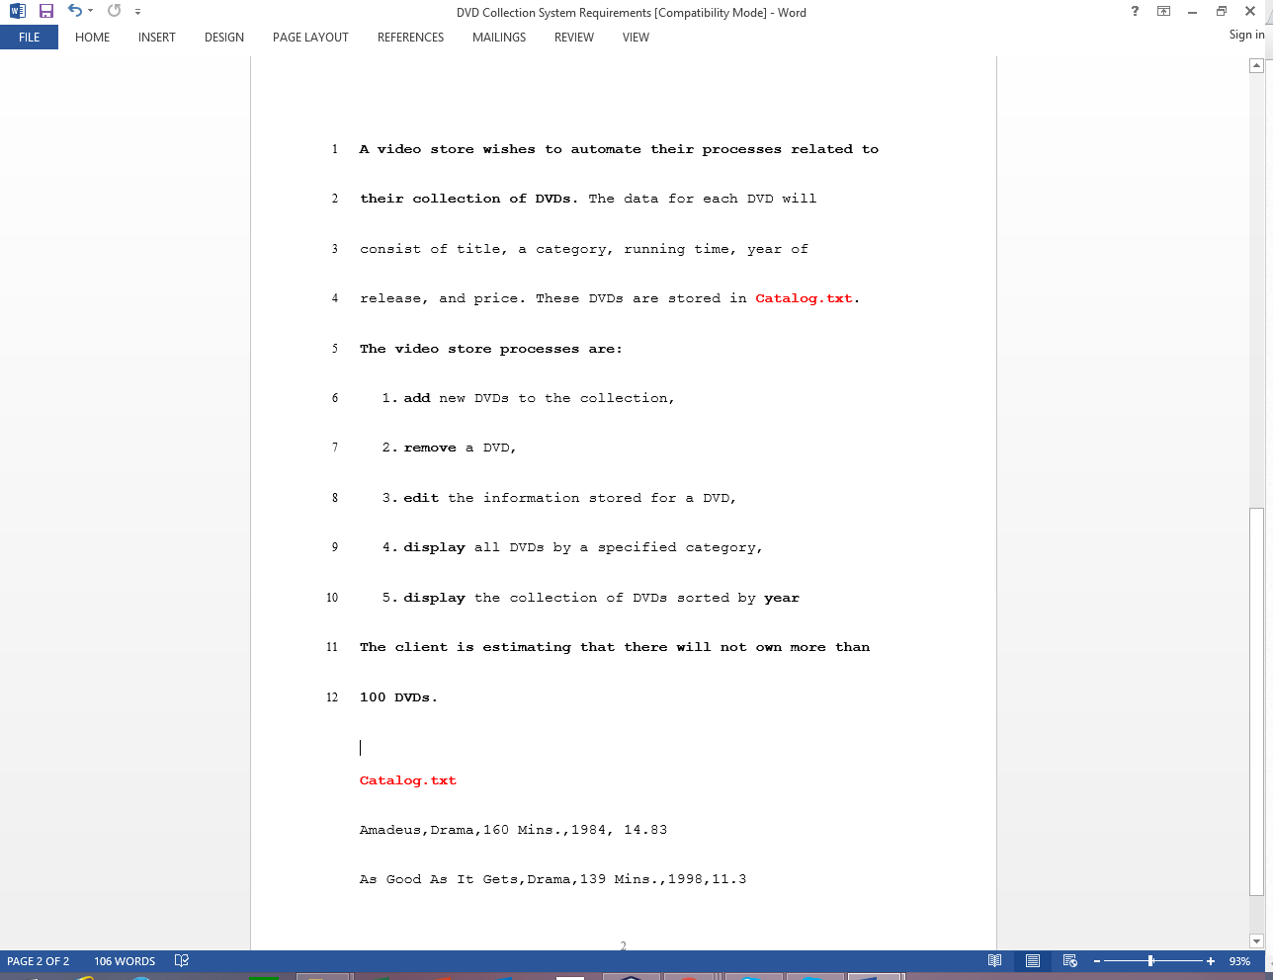

1. (200 points)

**Given the above DVD Catalog Application above, convert the UML MVC Class Diagram Model to C# Classes and only implement the restore Catalog (using the given Catalog.txt), add DVD, display DVDs by category and save Catalog (using the given Catalog.txt).**

**(Must use an IDE, without it only half).**

**Answer:**

**Code here for each .cs file (one Class per file).**

**Full screen screenshot (output window, source window with first few lines of comments showing your name and Spring 2021)**

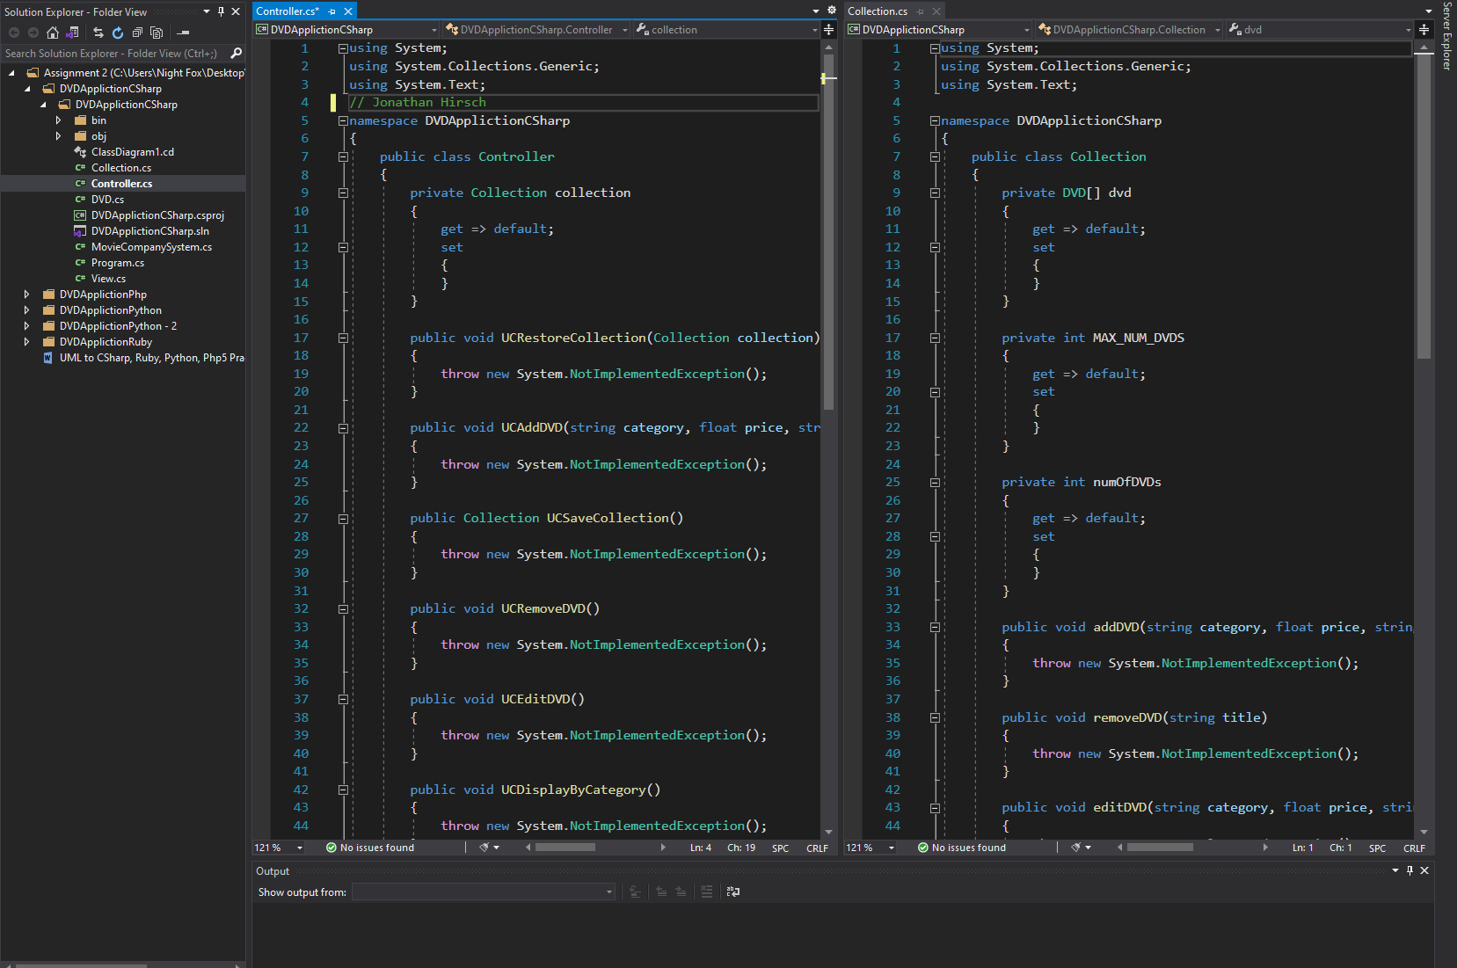

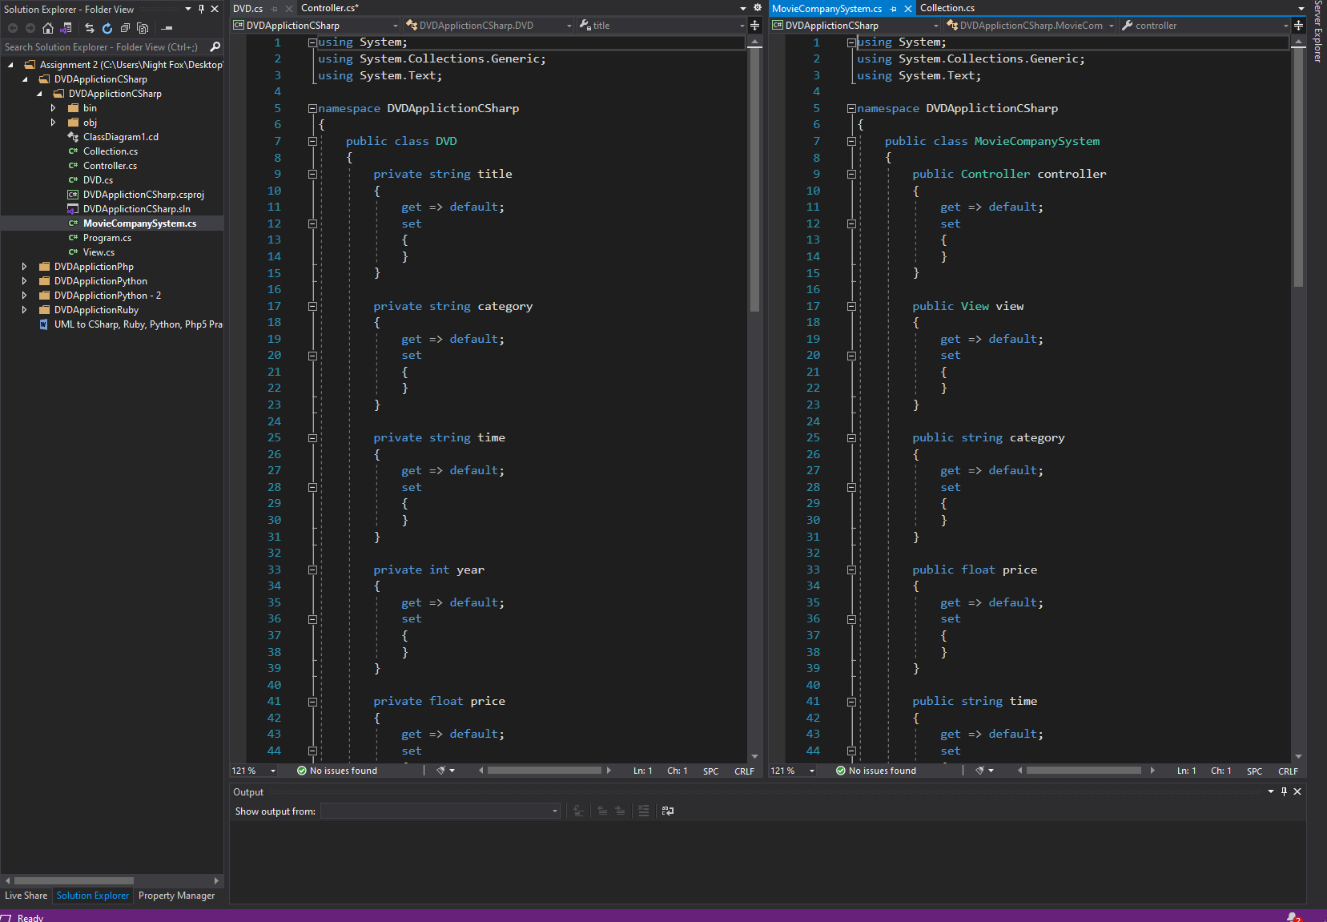

2. (200 points)

**Given the above DVD Catalog Application above, convert the UML MVC Class Diagram Model to Ruby Classes and only implement the restore Catalog (using the given Catalog.txt), add DVD, display DVDs by category and save Catalog.**

**(Must use an IDE, without it only half).**

**Answer:**

**Code here for each .rb file (one Class per file).**

**Full screen screenshot (output window, source window with first few lines of comments showing your name and Spring 2021)**

3. (200 points)

**Given the above DVD Catalog Application above, convert the UML MVC Class Diagram Model to Python Classes and only implement the restore Catalog (using the given Catalog.txt), add DVD, display DVDs by category and save Catalog.**

**(Must use an IDE, without it only half).**

**Answer:**

**Code here for each .py file (one Class per file).**

**Full screen screenshot (output window, source window with first few lines of comments showing your name and Spring 2021)**

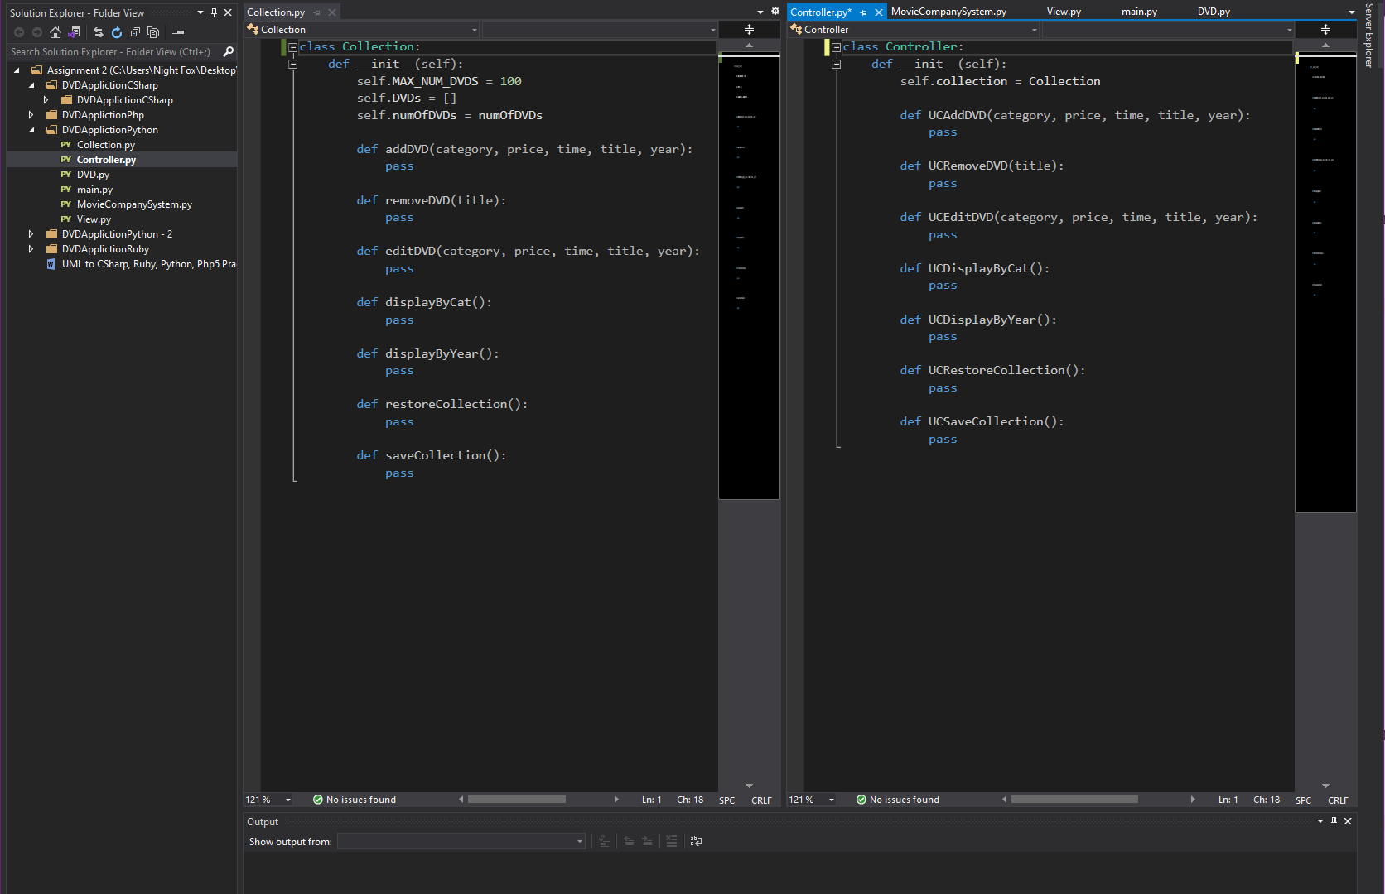

4. (200 points)

**Given the above DVD Catalog Application above, convert the UML MVC Class Diagram Model to Php Classes and only implement the restore Catalog (using the given Catalog.txt), add DVD, display DVDs by category and save Catalog.**

**(Must use an IDE, without it only half).**

**Answer:**

**Code here for each .php file (one Class per file).**

**Full screen screenshot (output window, source window with first few lines of comments showing your name and Spring 2021)**

**NOTES: Ruby, Python, Php are supported in NetBeans 6.9.1 IDE (or newer versions by importing plugins). Any other IDEs are OK.**

**NOTES: C# is supported by Visual Studio IDE.**

**\* Java is supported in NetBeans IDE. It is ok if one of your UML to OO Language is Java.**